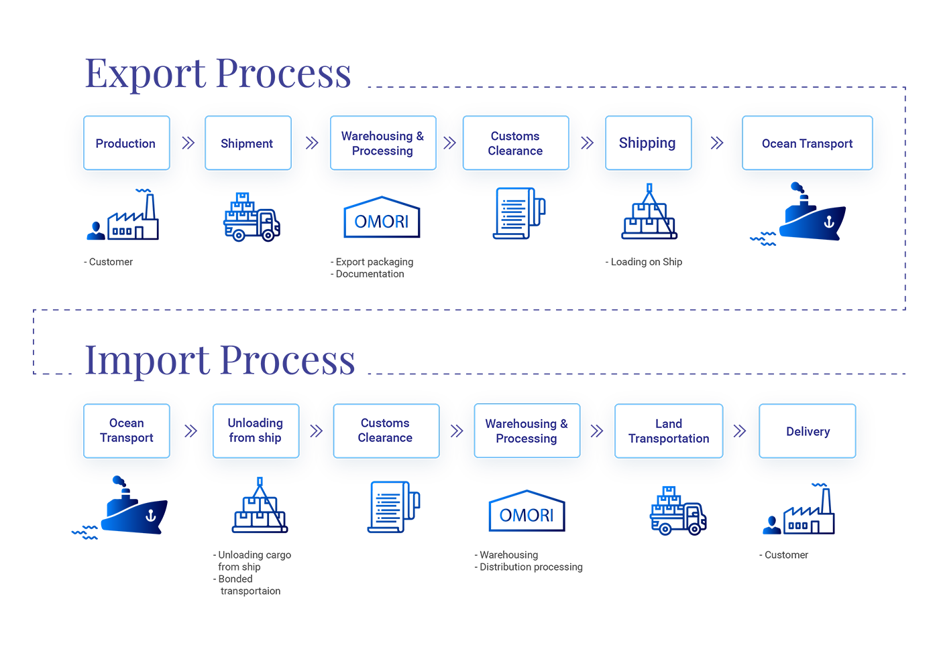

FIGURE : - IMPORT / EXPORT PROCESS FLOW CHART